**CAMBRIDGE INSTITUTE OF TECHNOLOGY**



***-***

***Innovation Manifested***



**Unveiling the Technologies, Talents and Hobbies**

**DEPARTMENT OF COMPUTER SCIENCE AND ENGINEERING**

# PROJECT TITLE : Obstacle sensing robot

**ABSTRACT:**

Obstacle detection and avoidance can be considered as the central issue in designing mobile robots. This technology provides the robots with senses which it can use to traverse in unfamiliar environments without damaging itself. In this paper an Obstacle Avoiding Robot is designed which can detect obstacles in its path and maneuver around them without making any collision. It is a robot vehicle that works on Arduino Microcontroller and employs three ultrasonic distance sensors to detect obstacles. The Arduino board was selected as the microcontroller platform and its software counterpart, Arduino Software, was used to carry out the programming. The integration of three ultrasonic distance sensors provides higher accuracy in detecting surrounding obstacles. Being a fully autonomous robot, it successfully maneuvered in unknown environments without any collision. The hardware used in this project is widely available and inexpensive which makes the robot easily replicable.

**DESCRIPTION OF THE PROJECT:**

This project developed an obstacle avoiding robot which can move without any collision by sensing obstacles on its course with the help of three ultrasonic distance sensors. Robots guided with this technology can be put into diversified uses, e.g., surveying landscapes, driverless vehicles, autonomous cleaning, automated lawn mower and supervising robot in industries. The robot developed in this project is expected to fulfill the following objectives:

• The robot would have the capacity to detect obstacles in its path based on a predetermined threshold distance.

• After obstacle detection, the robot would change its course to a relatively open path by making autonomous decision.

• It would require no external control during its operation.

• It can measure the distance between itself and the surrounding objects in real-time.

• It would be able to operate effectively in unknown environment.

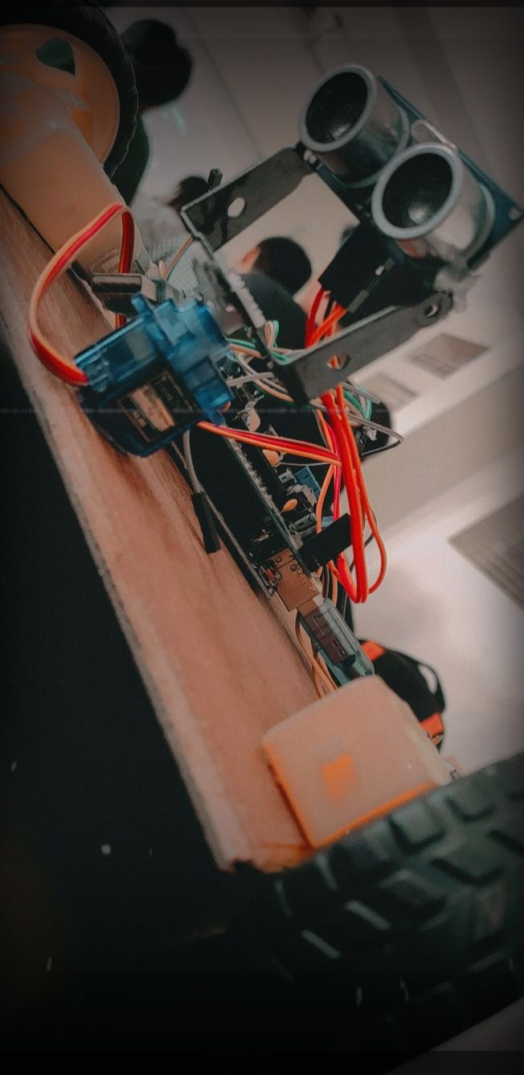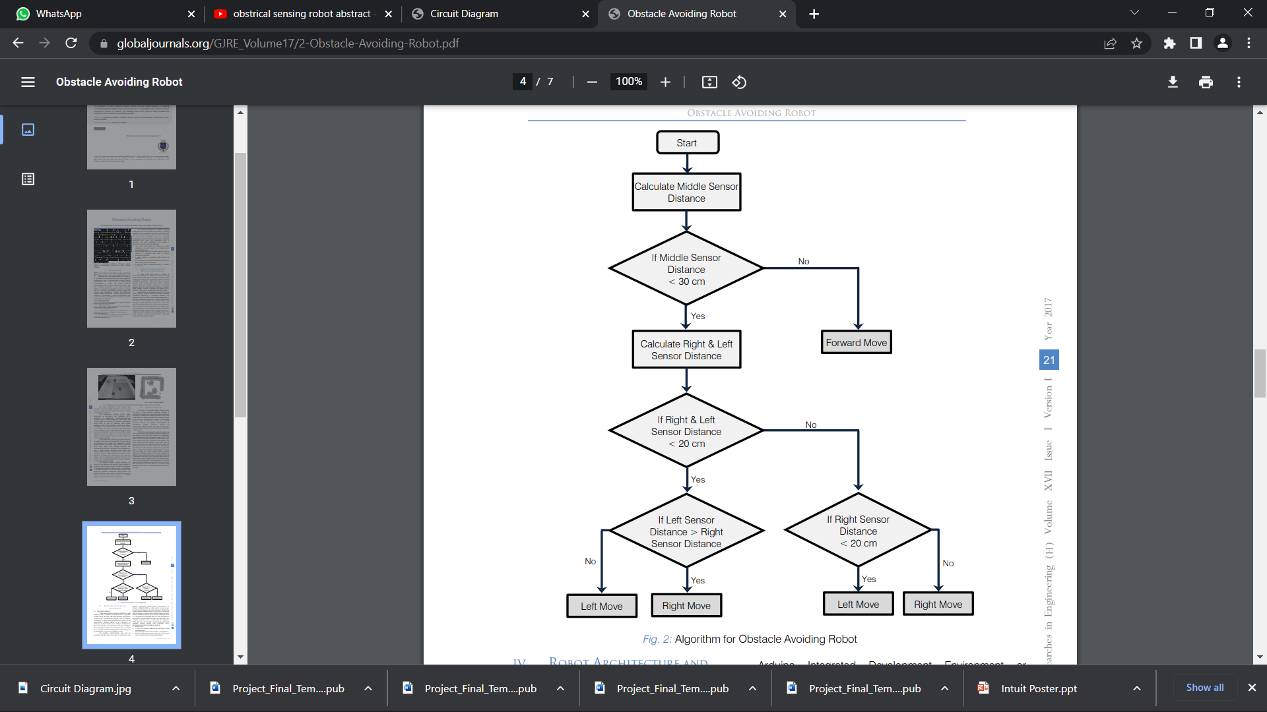

|  |  |
| --- | --- |
| **TEAM MEMBERS WITH USN:** | **PROJECT GUIDE/COORDINATOR:** |
|  |  |
| **1)D.Manoj 1CD21AI010** | **1)** Prof. Yashaswini S |
| **2)Dev tarun 1CD21AI009**  **3) Achala 1CD21AI018** |  |